**Moment of a force.**

The moment 𝐌𝐨 **about point O**, or about an axis passing through O and

Perpendicular to the plane, **is a vector quantity** since it has a specified

**Magnitude and direction** (fig).

The magnitude of **Mo** is **𝑀𝑜 = 𝐹. 𝑑**

Where *d* **is the moment arm** or **perpendicular distance from the axis at**

**point O** to the line of action of the force. **Units** of moment is **N.m** or **lb.ft**.

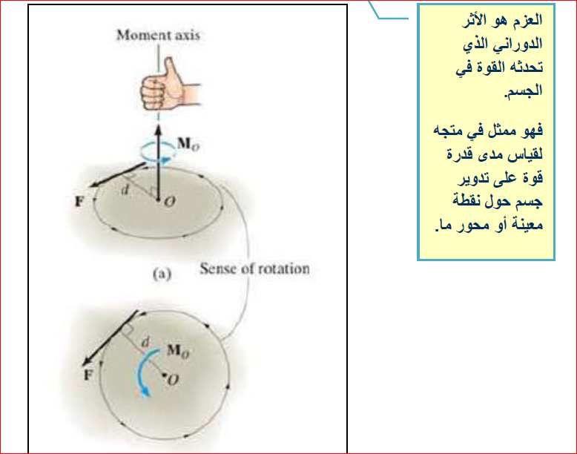

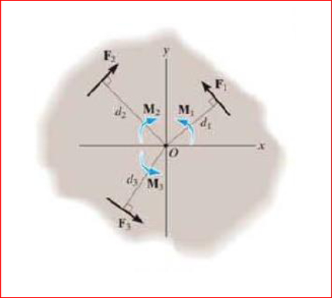

𝑀o =- 𝐹1𝑑1 + 𝐹2𝑑2 - 𝐹3𝑑3

إتفاق : يعتبر العزم موجب اذا كان اتجاهه هو نفس عقرب الساعة ويعتبر سالب اذا كان اتجاهه عكس عقرب الساعة

Moment: Tendency to rotate; torque

Moment about a point: M = Fd

Magnitude of moment is proportional to the force ‘F’ and

moment arm ‘d’ i.e, **perpendicular distance** from the axis of rotation to the LOA of force.

UNIT : N.m

Moment is perpendicular to plane about axis O-O

***Counter CW = - ve ; CW = +ve***

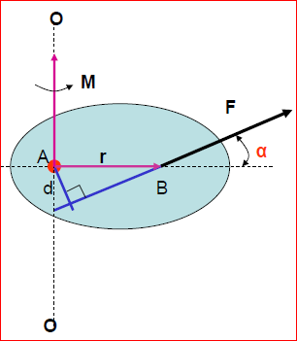

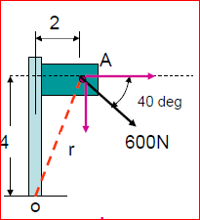 Example : Calculate the magnitude of the moment about ‘O’ of the force 600 N .

***Solution***

Mo = 600 cos 40 (4) + 600 sin 40 (2)

= 2610 N.m

Example : For each case illustrated below, the moments of the forces are:

|  |  |  |
| --- | --- | --- |
| a | b | c |
| d | e | f |

***Exercise 1:***

The two boys push the gate with force of 𝐹𝐴 = 30 lb and 𝐹𝐵 = 50 lb as shown. Determine the moment of each force about C. Which way will the gate rotate clockwise or counterclockwise Neglect the thickness of the gate.

***Exercise 2:***

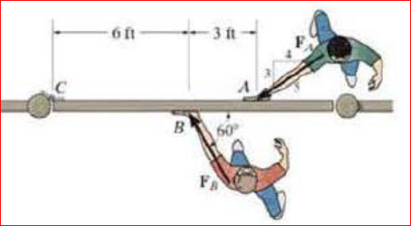Two boys push on the gate as shown. If the boy at B exerts a force of FB = 30 lb , determine the magnitude of the force FA the boy at ***A*** must exert in order to prevent the gate from turning. Neglect the thickness of the gate.

***Exercise 3:***

Determine the resultant couple moment of the three couples acting on the plate in figure .

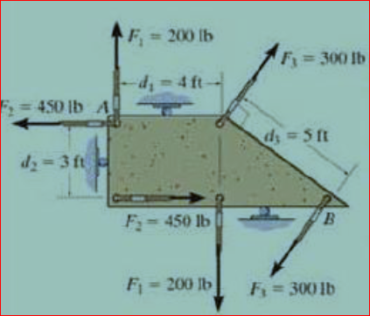

***Exercise 4:***

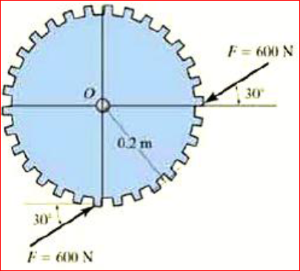Determine the magnitude and direction of the couple moment acting on the gear in figure.

***Exercise 5:***

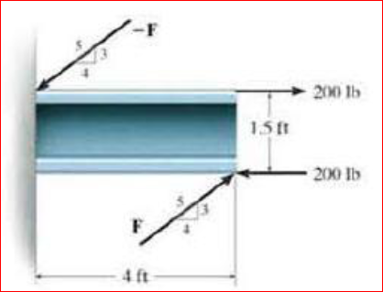Two couples act on the beam as shown. Determine the magnitude of F so that the resultant couple moment is 300 lb.ft counterclockwise . Where on the beam does the resultant couple act?