**Higher Education & Scientific Research Ministry**

**Al-Mustafa University College**

**Civil Engineering Department**

**Third Stage**

**Traffic Engineering**

**Syllabus:**

1-Traffic administration and planning

2-Traffic studies (volume, speed, capacity, delay, ....)

3-Traffic stream characteristics (Traffic flow theory)

4-Geometric design (elements and control)

5-Traffic signal

6-Intersection and interchange

7-Cross section elements

8-Parking

**References:**

1-Roger P.Ross, Elena S.prassas, Willion R.Mcshane ''Traffic Engineering'' ,3rd edition, 2004.

2-Nichols J.Garber, Lester A Hoel, ''Principles and Practices of Traffic and Highway Engineering'', 2nd edition,1999.

3-Gordon wells, ''Traffic Engineering an introduction'',2nd edition,1979.

4-Fred L.Mannering , walter P.kilareski ''Principles of Highway and Traffic Analysis'',2nd edition,1998.

5-L.R.Kadyali, N.B.lal, ''Highway Engineering'' 4th edition, 2006.

**Chapter One**

**Introduction:**

**Traffic engineering: -**

One of the main engineering branches in which it deals with the planning, geometric design and traffic operation of facilities (Transportation systems, highway, free way, expressway, railway, airport waterway, pipeline, ….,parks) which enable us to transport passenger and goods from one place to another by efficiently and economically.

**Transportation engineering: -**

Is the application of technology and scientific principles to the planning, functional design, operation and management of facilities for any mode of transportation in order to provide for the safe, rapid, comfortable convenient, economical and environmentally compatible movement of people and goods.

**Transportation modes: -**

1-Roads

2-Rail

3-Air

4-Maridime

5-Pipe line

**Phases of traffic Engineering: -**

1- Speed, travel time and delay

* Traffic volume and capacity
* Origin and destination (survey)

2- Traffic operation: - Especially for regularity measures ordinary for purposes of driver, vehicles and pedestrians and for control of intersections and speed.

**Traffic control Devices: -**

It is mean design, installation, operation and maintenance of traffic signs, signals and pavement marking.

**Traffic** **Planning: -**

This phase of traffic engineering deals with the planning of traffic facilities.

**Traffic Administration: -**

Administration and legal agency of traffic control and regulation traffic engineering is concerned with administration frame work and organization of traffic engineering department.

**Traffic** **Planning**:

**CBD (Central Business District)**

* **Urban areas Residential areas**

**Industrial areas**

* **Rural areas**

**Traffic** **Planning**

**Urban areas Rural areas**

**CBD Resid. Indus.**

**areas areas**

**Highway classification:**

1. **Physical classification**
2. **Functional classification**

**A-Physical classification**: - could be classified into:

1- Two – lane two way Hgw: a highway having two lane cross section with one lane for each direction of traffic flow (not divided).

2-Multible lane Hgw: a physical having two lane or more in each direction (two lane at least). This type of highway is either divided by physical medians or undivided.

divided undivided

* Physical median

**B- Functional classification:**

* **Rural areas**

1. **Interstate highway system**

* High ways of international importance, and including highways connecting major cities.
* Servicing through movement exclusively.

1. **Primary highway system**

* High ways of international importance &highways of special importance.
* including highways connecting smaller cities.
* through movement**,** some land access.

1. **Secondary highway system**

* highways connecting major citiesof economical or other importance, highways connecting agricultural, commercial, recreational.
* Small cities and outlying regions.
* through movementand land access.

**4. Tertiary highway system**

* Highwaysof district and local importance.
* Land access, some through movement.
* Farm to market.
* **Urban areas**

1. **Principal Arterials (freeway & expressways)**

* Provides rapid &efficient movement of large volumes of through traffic between areas and across urban area.
* Full control of access.
* Long trip.
* Divided.

1. **Transition (ramps)**

* For general increase or decrease in speed.

1. **Minor Arterials (Distributions)**

* Relatively long trip.
* Provides through traffic movement between areas and across the city with direct access to butting property.

1. **Collectors (Major or Minor)**

* Provides traffic movement between minor arterials &local streets with direct access to abutting property.
* Short trip =1 mile.

1. **Local street or road**

* Provides for direct access to abutting land and for local traffic movement.
* Very short trips =1/2 mile.

1. **Terminal (destination)**

* Off – street parking
* 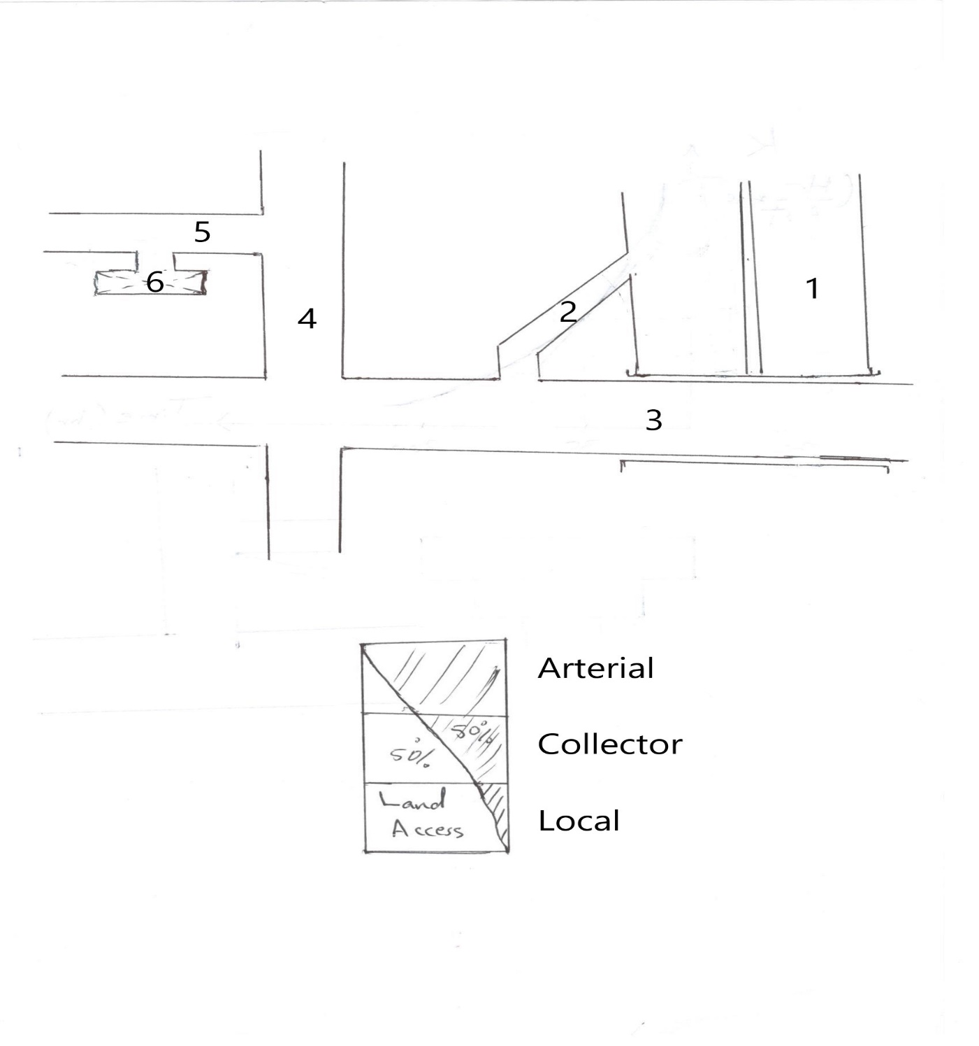Bus stops.

**Chapter Two**

**Traffic studies**

**Part 1**

**Traffic volume: -** the number of vehicles that pass over a given section of a lane or road way during a specified period of time. {vehicle/unit time} (veh/hr).

* Time period (hourly or sub hourly, weekly, daily, annual and depends on the purpose of study)
* Volume studies are necessary for: -

1. The relative importance of any route.
2. The fluctuation in flow.
3. The distribution of traffic on the road system.
4. The trends in the road use especially for accidents.

* **Methods of counting the traffic volume:**

1. Manual method. (Human with Mech. Counter)
2. Automatic method. (Electrical, Mechanical, Magnetic, Photo, Radar, ……etc.)

**Traffic volume types: -**

1. **Annual Average Daily Traffic (AADT): -** the total yearly volume divided by the number of days in the year (365 day). [veh/day or vpd]commonly abbreviated as AADT.

**AADT are used for: -**

1. Estimation ofhighwayuser revenues.
2. Computation of accident rates.
3. Establishment of traffic volume tends.
4. Evaluation of the economic feasibility of highway projects.
5. Development of freeway and major arterial street systems.
6. Development of improvement and maintenance programs.
7. **Average Daily Traffic (ADT): -** the total volume during a given time period in whole days greater than one day and less than one year divided by the number of days in that time period ( veh/day or vpd). Commonly abbreviated as ADT.

**ADT may be used for: -**

1. Planning of highway activities.
2. Measurement of current demanded.
3. Evaluating of existing traffic flow.
4. Computing accidents rates.
5. **Current ADT (CADT): -**the number of vehicles that pass through a section of roadway in one day usually calculated for two way unless otherwise specified. (veh/day or vpd)
6. **Future ADT (FADT): -** it mean:
7. Current ADT →Existing Attractive volume.
8. Traffic increase → Normal traffic growth or generated traffic development.

$$FADT=CADT*{(1+r)}^{x+η}$$

Where:

$r$ = annual rate of increasing in traffic (6 - 9)%

$x$ = years of construction (2 years).

$η$ =design life of road (20-25) years.

${(1+r)}^{x+η}$: traffic projection factor (T.P.F)

1. **Design Hourly volume (DHv) or (30Hv)**

Future peak hourly volume used in design which is used neither exceeded too often nor being rarely obtained (vph or veh/hr).

Then:

**DHv (Two Way) ↔ 30 Hv (Two Way)**

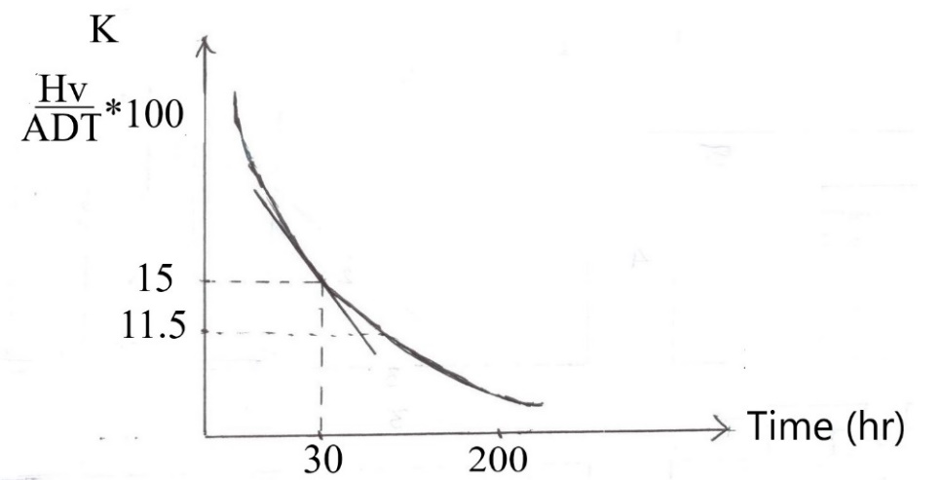**Thirtieth Highest(Hv): -** used in design in which mean (the hourly volume that exceeded by 29hr volume during a design year).

Where:

K= $\frac{One way DHv}{One way futur ADT}$

(K) Varies from (0.12) to (0.18)

Thus

30 Hv = (0.12 FADT to 0.18 FADT)

So can take it (0.15 FADT)

**DHv are used for the following purposes: -**

1. Determining of the deficiency in (capacities, geometric, design,…..)
2. Determining of the lanes number and width of lane.
3. Planning the traffic control (signs, signal).
4. Location of interchange.

**F. Peak hourly volume (PHv): -**Number of vehicles that pass a point on a highway section during peak period intervals (veh/hr or vph).

**Rate of flow (V): -**The equivalent rate at which vehicles pass over a section or point through a lane or road way during a given time interval less than one hour usually (15 min.) or (5 min.).

PHF= $\frac{Hourly volume (Hv)}{Max. rate of flow(V)}$

Where: PHF: Peak Hourly Factor.

**Example: -Find the PHF for the given data?**

|  |  |
| --- | --- |
| **Volume of veh/15min.** | **Time interval** |
| **1000**  **1100**  **1200**  **900** | **5:00_5:15**  **5:15_5:30**  **5:30_5:45**  **5:45_6:00** |

**Solution: -**

**∑**volume= 1000+1100+1200+900=4200 veh/hr

Then:

Rate of flow= 4 * volume/15min.

Then:

|  |
| --- |
| Rate of flow |
| 1000 * 4 =4000  1100 * 4 =4400  1200 * 4 =4800 max. rate of flow (v)  900 * 4 =3600 |

Then:

PHF= $\frac{Hourly volume (Hv)}{Max. rate of flow(V)}$ = 4200/4800 = 0.91

**Example: - Find the following:**

**1-ADT**

**2-AADT**

**For data in the table below?**

|  |  |  |  |  |  |  |  |  |  |  |  |  |
| --- | --- | --- | --- | --- | --- | --- | --- | --- | --- | --- | --- | --- |
| Month | 1 | 2 | 3 | 4 | 5 | 6 | 7 | 8 | 9 | 10 | 11 | 12 |
| No. of days | 31 | 28 | 31 | 30 | 31 | 30 | 31 | 31 | 30 | 31 | 30 | 31 |
| No. of vehicles*103 | 425 | 440 | 385 | 400 | 450 | 500 | 580 | 570 | 490 | 415 | 420 | 400 |
| Solution Then:  ADT=vpd ${10}^{3}$* | 13.71 | 14.64 | 12.4 | 13.3 | 14.50 | 16.60 | 18.70 | 18.30 | 16.30 | 13.38 | 14.0 | 12.90 |

Solution

AADT=14.91 ${10}^{3}$* vpd?

**Traffic Volume Data Presentation: -**

1. 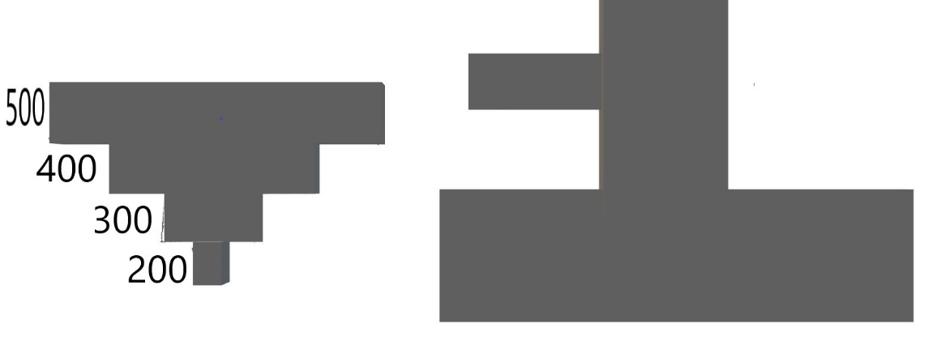Traffic flow maps: - traffic volume on each route is represented by width of band.
2. Intersection summary sheets:

Intersection --------------------------

Data ---------------------- Day -----------------

Observer ----------------------------------

City ---------------------------------

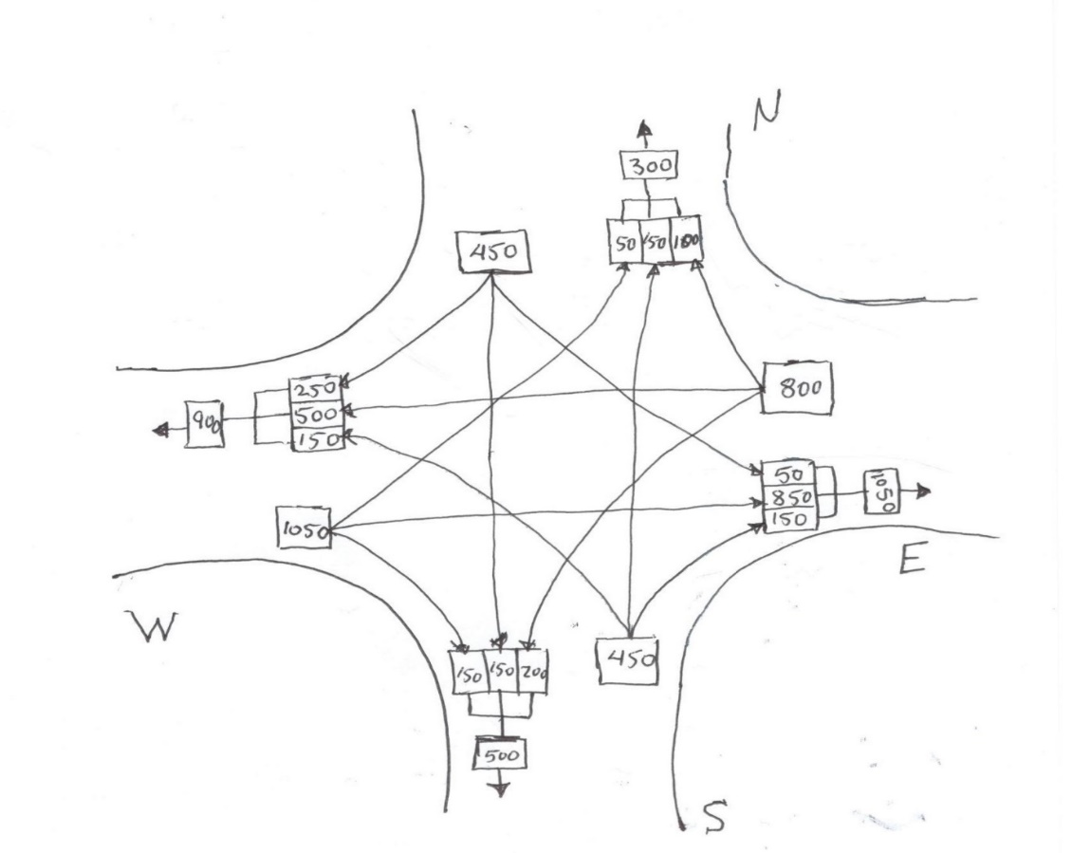

1. **Summary Tables: -**Summary tables traffic volume data on highway section.

**Types of traffic vehicles: -**

1. Passenger car unit (P-vehicle or PCU) including pickup<4 tons.
2. Motor cycle.
3. Single unit truck (SUT) and small buses.
4. Semi-trailer truck (STT) and big buses.
5. Heavy good vehicle (HGV) (combination).

|  |  |  |  |  |  |
| --- | --- | --- | --- | --- | --- |
| Type | 1 | 2 | 3 | 4 | 5 |
| Width | 2.10 | - | 2.60 | 2.60 | 2.60 |
| Height | 4.10 | - | 4.10 | 4.10 | 4.10 |
| Length | 5.8 | - | 12.0 | 16.5 | 20.0 |

**Types of axels for truck: -**

1. Single axel with a single tire on each side

near 6 tons.

1. Single axel with a dual tire on each side

near 12 tons.

1. Double axel with a dual tire on each side

near 18 tons.

1. Group of three axel with a dual tire on each side

near 25 tons.

Max. gross weight = 60 tons.

Turning paths varies and depends on the type of vehicle.

Max. allowable tire pressure = 95 psi in Iraq (60-90) in USA.

**Conversion Factor**: -depends on the type of vehicle and area.

|  |  |  |  |
| --- | --- | --- | --- |
| Vehicle type | flat | rolling | mountainous |
| a-PCU | 1 | 1 | 1 |
| b-SUT | 1.25 | 1.75 | 3 |
| c-STT | 2 | 3 | 6 |
| b-HGV | 3 | 5 | 10 |

Ex: - Given mixed traffic volume = 5000 vpd in mount. Areas and have the composition.

a/ 70% , b/ 20% , c/ 6% , d/4% .

Find equivalent volume expressed for PCU?

Solution: -

Equivalent traffic volume = [0.7*1+0.2*3+0.06*6+0.04*10] * 5000

=10300 PCU pd or PCU/day

Then:

We can expressed for **C.F** by the following equation: -

**C.F $= \frac{[100+P_{S}\left(E_{S}-1\right)+P_{T}\left(E_{T}-1\right)+P_{H}(E_{H}-1)}{100}$**

**Where:**

**C.F :** Passenger Car Conversion Factor

$P_{S},P_{T},P_{H}$: Proportions of other types of vehicles.

$E_{S},E_{T},E_{H}$: Passenger Car Equivalent for other types of vehicles.

**Expanding and adjusting traffic volumes counts: -**

It is necessary to expand short count to common base (like AADT). Expansion factors, used to adjust periodic counts, are determined either from continuous (permanent) or control count stations.

Hourly, daily and monthly expansion factors can be determined using data obtained at continuous count stations, as follows: -

1. **Hourly Expansion Factor (HEF)**
$$HEF=\frac{total volume for 24 hr period}{volume for aparticular hour}$$

$$24 hr volume= \frac{\sum_{i=1}^{n}{\left(hourly volume \right)*(HEF)}}{n}$$

2. **Daily Expansion Factor (DEF)**
$$DEF=\frac{Average total volume for week period}{Average volume for aparticular day}$$

3. **Monthly Expansion Factor (MEF)**

$$MEF=\frac{AADT}{ADT for aparticular month}$$

Example: - A traffic engineer need to determine the AADT on a rural primary road. He collected the data shown below on a Tuesday during the month of May. Determine the AADT of the road if the required expansion factor are given.

|  |  |  |
| --- | --- | --- |
| Time period | Hourly volume collected | HEF |
| 7:00 – 8:00  8:00 – 9:00  9:00 – 10:00  10:00 – 11:00  11:00 – 12:00 | 400  535  650  710  650 | 29.00  22.05  18.80  17.10  18.25 |

DEF (Tuesday) = 7.727

MEF (May) = 1.394

Solution: -

Estimate 24 hr volume for (Tuesday) = $\frac{\sum_{i=1}^{n}{\left(hourly volume \right)*(HEF)}}{n}$

$=\frac{\left(400*29\right)+\left(535*22.05\right)+\left(650*18.8\right)+\left(710*17.1\right)+(650*18.5)}{5}$

= 11959 vpd

Total 7 - day volume = 11959*7.727 = 92407

Average 24 hr volume = $\frac{92407}{7}$ =13201 vpd

AADT = 13201* 1.394 = 18402 vpd

**Measurements of traffic volume: -**

1. **Manual count: -**includes an observer records on field sheet, the passage of each vehicle according to its classification (passenger car, bus, truck,..)

**Advantage: -**

1. Flexibility and location can be changed at will simple & quick.
2. Don’t required high skill.
3. Permits traffic classification by vehicle type.
4. Cheep for short sample counts.

**Disadvantage: -**

1. Expensive for long period of counting.
2. Human factors limitation.

**2. Mechanical count: -**includes the use of mechanical devices which can automatically count and record the data.

* Detector
* Counter

It is considered permanent and portable.

* Some types of detectors: -

1. Pneumatic tube detector.
2. Magnetic loop detector.
3. Photo electric detector.
4. Radar detector.
5. **Moving vehicle method: -**

A test vehicle makes round trip s (6-16) on a test section like the one shown in the figure below: -

Nourth A A

Ms On

Ts Pn

Tn

South B B

The method is applicable to two-way routes only. It has been found to be economical and to produce satisfactory, unbiased, estimates of volume and travel time. Selected depend on:

-physical condition (width, number of lanes, …)

-traffic condition (volume, speed, ….)

The observer starts collecting the data at section (A-A), drives the car south bound to section (B-B) and then turns the car around and drives north bound to section (A-A) again.

The following data are collected:

* Travel time when traveling south, Ts, in minutes, obtained by stop watch.
* Travel time when traveling north, Tn, in minutes (B-B) to (A-A).
* Opposing traffic count of vehicles met when the test car was traveling south, Ms, (vehicles).
* The number of vehicles that overtake the test car, while it is traveling north (B-B) to (A-A), On.
* The number of vehicles that test car passes while it is traveling north (B-B) to (A-A), Pn.

**From this data we can find:**

-Hourly volume in north bound direction:

Vn = (vph)

-Average travel time for one direction flow:

Tn\ = Tn -

-Average travel space mean speed for one direction flow:

Sn =

Where: -

Vn = volume per hour, north bound (for south bound volume all subscript are reversed).

Ms = opposing traffic count of vehicles met when the test car was traveling south.

On = no. of vehicles overtaking the test car while traveling north.

Pn = no. of vehicles passed by the test car while traveling north.

Tn = travel time when traveling north, in minutes.

Ts = travel time when traveling south in minutes.

Tn\ = average travel time of all traffic north bound.

Sn = space mean speed north bound.

Example:-Data for test section length (1km) on major arterial is given below:

|  |  |  |  |  |
| --- | --- | --- | --- | --- |
| North bound trips | Travel time (min) | No. of vehs. Traveling in opposite dir. | No. of vehs. That overtake test car | No. of vehs. Overtaken by test car |
| 1  2  3  4  5  6  average | 2.65  2.7  2.35  3  2.42  2.54  2.61 | 85  83  77  85  90  84  84 | 1  3  0  2  1  2  1.5 | 0  2  2  0  1  1  1.0 |
| South bound | Ts | Ms | Os | Ps |
| 1  2  3  4  5  6  average | 2.33  2.3  2.71  2.16  2.54  2.48  2.42 | 112  113  119  120  105  100  111.5 | 2  0  0  1  0  0  0.5 | 0  2  0  1  2  1  1.0 |

**Solution:**

Vn = = = 1336 veh/hr

Vs = = = 996 veh/h

Tn\ = Tn - = 2.61 - $\frac{60(1.5-1.0)}{1336}$ = 2.56 min.

Ts\ = Ts - = 2.42 - $\frac{60(0.6-1.0)}{996}$ = 2.45 min.

Sn = = = 23.2 Km/hr

Ss = = = 24.5 Km/hr

**4. Photographic Techniques.**

**Directional Distribution Factor (D.D): -**

one way hourly volume in certain direction of travel as a percent of two way design hourly volume.

Where:

D.D = $\frac{one way Hv}{Two way DHv}*100$

Then:

The factor can be used to convert DHv (two – direction) to hourly vol. travelling in peak direction, and it ranged between (50 – 80)%

Thus:

DDHv = FADT * K * D.D

Where:

DDHv = Directional distribution of design hourly vol. (veh/hr)

Thus: it could be possible to find the No. of lane as:

Number of lane (one direction) = $\frac{Hv for one way}{Net design capacity (Net.D.c)}$

Where:

Net D.c = total capacity – shortcoming

:. Total No. of lanes = 2* No. of lanes for one direction.

Example:

Given 30Hv = 5000 vpd

D.c = 1000 vpd / lane

D.D = 1. = 60%

= 2. = 80%

find No. of lanes for each case?

Solution: -

1. D.D = 60%

D.D = $\frac{one way Hv}{Two way DHv (30Hcv)}$

Then : one way Hv = D.D * 30Hv = $\frac{60}{100}*5000=3000 vpd/direction$

No. of lanes for one direction = $\frac{one way Hv (3000)}{Net. D.c (1000)}$ = $3.0 lane/direction$

Then:

Total No. of lane = 2* No. of lanes for one direction = 2*3 = 6.0 lanes

1. D.D = 80%

As mentioned previously, one way Hv = D.D * 30Hv

$$=\frac{80}{100}*5000=4000\frac{vpd}{direction}$$

$$then: No.of lane for one direction= \frac{4000}{1000}=4.0 lane/direction$$

$$then: Total No.of lanes =2*4=8.0 lanes$$

**Chapter Two**

**Traffic studies**

**Part 2**

**Traffic Speed Studies:**

Speed: is the rate of motion in distance per unit time, generally expressed in kilometer per hour (km/h) or mile per hour (mile/hr).

$s=\frac{d}{t}$, where: s= speed, d= distance, t= time of traverse distance.

1. **Spot speed:-**

**Spot speed:**

**-** is the instantaneous speed of vehicle at any specified point.

**Average spot speed**: - is the arithmetic mean of the speeds of all traffic at a specified points.

**Application of spot speed data: -**

some of the spot speed data application:

1. For speeds at problem locations.
2. For traffic operation (regulation and control)
3. Establishing speed limit.
4. Determining safe speed at carves and intersection approaches.
5. Locating traffic signs.
6. For accident analysis.
7. **Overall travel speed (journey speed):**

It is the effective speed of vehicle between two points and it is found by dividing the distance between the two points by the total time taken by the vehicle to complete the distance including stoppage time due to traffic delays and traffic control devices.

\***Operating speed: -**

It is the highest overall speed at which a driver can travel on a given highway under favorable weather and traffic condition without exceeding

the design speed.

1. **Average running speed:-**

Average speed over a particular area while the vehicle in motion and equals to length of the distance divided by the time the vehicle is in motion.

**Design speed:**

Maximum safe speed that can be maintained over a specified section when the conditions are so favorable that the design features of the highway govern.

**\*Selection of design speed depends on:**

-Type of highway and the purpose.

-Type of topography (terrain).

-Environmental condition.

-Economical conditions.

*Average running speed = 3/4 design speed.

Example: -

The speed of grouping is (5mile/hr) and the total number of observation (total frequency) equal 300.

Find:

1. Median speed.
2. Draw the frequency histogram.
3. Draw the frequency distribution curve.
4. Draw the cumulative frequency distribution curve.

|  |  |  |  |  |
| --- | --- | --- | --- | --- |
| Given | | Solution | | |
| Speed Group | No. of veh. | Mean speed of group | % of total observer | Cumulative of % observer |
| 10 – 15  15 – 20  20 – 25  25 – 30  30 – 35  35 – 40  40 – 45  45 – 50  50 – 55  55 – 60  60 – 65  65 - 70 | 0  6  8  29  60  63  74  29  19  10  2  0 | 12.5  17.5  22.5  27.5  32.5  37.5  42.5  47.5  52.5  57.5  62.5  67.5 | 0  2.0  2.7  9.7  20  21  24.7  9.7  6.3  33.3  0.7  0 | 0  2.0  4.7  14.4  34.4  55.1  80.1  89.8  96.1  99.4  100.1 |
| ∑300 | | ∑100% | | |

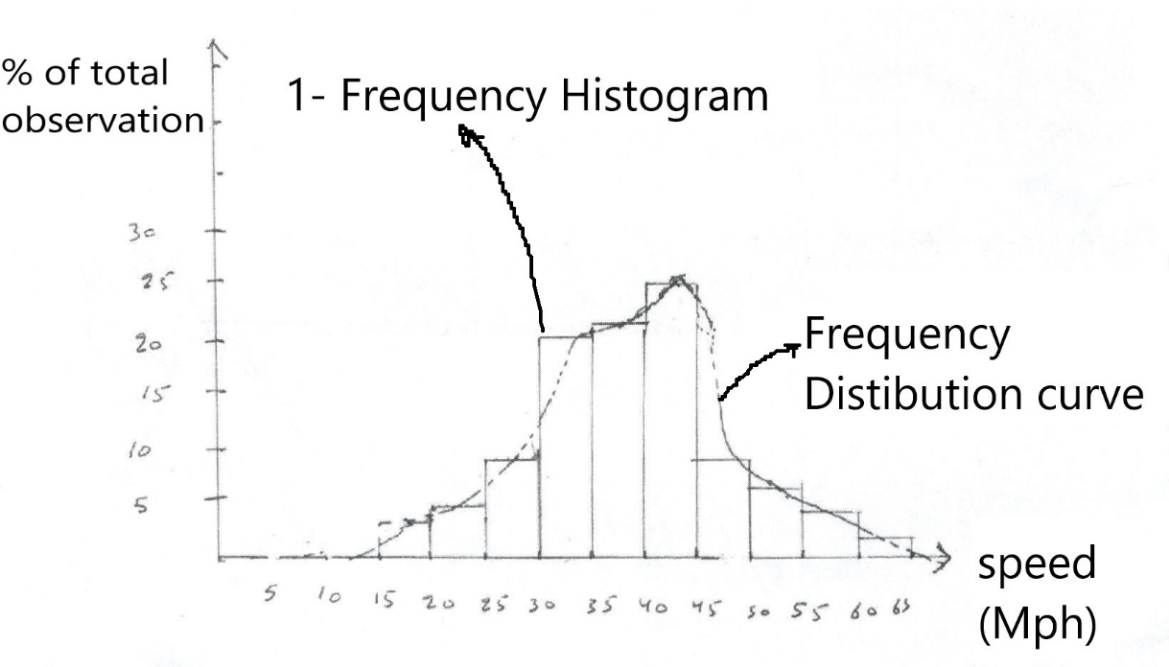

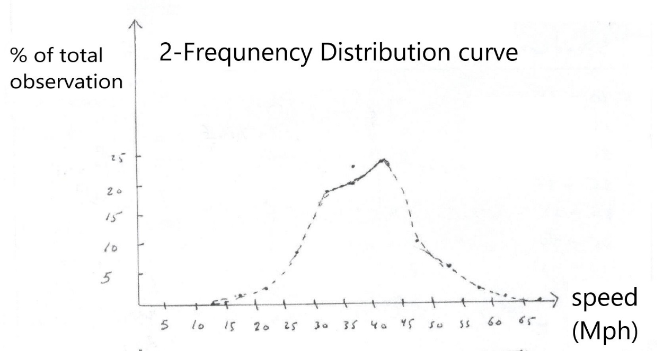

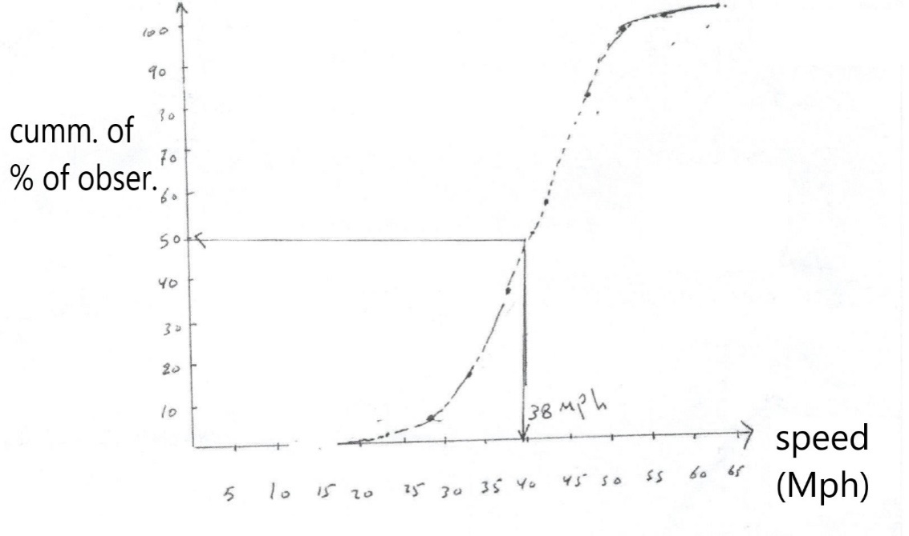

*Time mean speed (arithmetic mean speed).  
X $=\frac{∑f*v}{n}$

\

Where:

f:frequency of observation in each group [Col. 2].

v: mean speed for each group [Col. No. 3].

n: number of observed speed.

For our example mean speed= 36.46 mph.

**\*median speed: -**

It is the middle value in the distribution and identified as the (50th) precentral speed on the cumulative freq. dist. curve.

For our example P50 = 38 Mph.

**\*modal speed or mode speed: -**

It is the most frequency occurring value in the distribution

Mode speed = 42.50 mph.

**Space speed: -**

It is the (10 mile) range in speed in which the highest number of observation were recorded (10 mile/hr speed increment which cuts off). The pack of the freq. dist. curve

In our example space speed = (36.5 – 46.5) mph

**Chapter Two**

**Traffic studies**

**Part 3**

**Capacity: -**

The maximum rate of flow at which persons or vehicles can be reasonably expected to transfer a point or a uniform section of a lane or road way during a specified time period under prevailing condition (traffic, roadway, control) and usually expressed as (veh/hr/lane or person/hr/section)

OR it could be defined as:

The ability to accommodate traffic flow two conditions: -

1. Un interrupted flow (design capacity): Maximum no. of vehicles for one hour that can pass a lane or road way under conditions without delays or restrictions.
2. Interrupted flow (possible capacity): Maximum no. of vehicles for one hour that can pass a lane or roadway under condition regardless of their effects on delays or restrictions.

**Prevailing conditions: -**

1. 12' lane width (3.65 m).
2. Level grade.
3. No. curb parking on intersection approach.
4. All Pcu (passenger car unit).
5. All vehicles traveling through intersection.
6. The intersection located in a non – CBD area.
7. Green signal available at all times.

**Capacity of intersection: -**

Particular capacity: max. value of vehicles that pass the intersection from the approach in one hour of green time with most vehicles being able to clear the intersection during signal cycle.

*Each lane can pass one vehicles at 2.4sec. of green time (for lane width ≥ 3.65m).

Thus:

During passing time ( no. of vehicles/lane) = $\frac{60*60}{2.4}$ = 1500veh/green hr/ lane

**Example: -** cycle time 120sec. and green time = 40sec.

Find the no. of vehicles for each lane? then check the result width in the limits or no?

Solution: -No. of vehicles/lane = $\frac{40}{120}$* 1500 = 500 veh/cycle/lane

The limit of intersection (interrupted flow) = (400-700) veh/cycle/lane.

**Chapter Two**

**Traffic studies**

**Part 4**

**Traffic Delay Studies:** -

A delay study is made to determine the cause, location, duration and frequency of delays as well as overall travel and running speed.

**Delay: -**time lost while traffic is impeded by some element over which the driver has no control.

**Traffic Delay Types: -** there are two types: -

1. Operational or Congestion Delay: -

This is delay caused by interference between components of traffic, that is, the delay due to influences of other traffic. One type of operational delay is caused by other traffic movement that interfere with the stream flow (side friction), this includes parking vehicles, pedestrians, stalled vehicles, double parking and cross traffic.

A second type of operation delay is caused by interferences within the traffic stream (internal friction), this includes congestion due to high volumes, lock of road way capacity, merging or weaving maneuvers.

1. In case of main streets

Determine the average running speed when the traffic conditions are free moving and vehicles are not impeded and to call this reasonable running speed, normally max. value will be the speed limit is to be taken.

1. In case of city center street

Is to use the average spot speed measured at point where there is no impeded interference to traffic flow i.e. at point as for removed from intersection.

Example: -

Section of road length of 335 m, with average running time is 57 sec. under leaving traffic flow, where speed limit is 50 km/hr and average spot speed 26.9 km/hr, determine congestion delay in two case.

Solution: -

1. Running time at reasonable speed (50 km/hr)= $\frac{335}{50}*\frac{3600}{1000}=24 sec.$

congestion delay= 57 – 24 = 33 sec.

1. Running time at reasonable speed (26.6 km/hr)= $\frac{335}{26.9}*\frac{3600}{1000}=44.8sec.$

congestion delay= 57 – 44.8 = 12.2 sec.

1. Stooped or Fixed Delay: -

This delay occurs primary at intersection. It may be caused by traffic control devices (traffic signals, stop signs, yield signs and railroad crossings).

**Procedure: -**

1. Taking one approach to the intersection, one observer counts all vehicles for certain time period (5 or 10 min.) classify the traffic into "stopping" and "non stopping".
2. The second observer counts the No. of vehicles, stopped in the intersection approach at successive intervals (14 or 20 sec.).

The average stopping delay per vehicle

Delay = $\frac{(∑Vs)*I}{V}$ where: -

$∑Vs$ = Sum of stopped vehicle count.

$I$ = Interval between stopped vehicles.

$V$ = Total volume observed during study period (or approach volume).

Example: -

Data taking during a 5 min. study period. Find average delay per vehicle.

|  |  |  |  |  |  |  |
| --- | --- | --- | --- | --- | --- | --- |
| Time  (min.) | Total No. of vehicles stopped in approach at time | | | | Approach volume | |
| No. of stopping | No. of not stopping |
| + 0 sec. | + 15 sec. | + 30 sec. | + 45 sec. |
| 5:00 pm  5:01  5:02  5:03  5:04 | 0  4  9  1  5 | 2  0  16  4  0 | 7  0  14  9  0 | 9  3  6  13  2 | 11  6  18  17  4 | 6  14  0  0  17 |
| Sub total | 19 | 22 | 30 | 33 | 56 | 37 |
| total | $∑Vs$ = 104 | | | | $$∑V=93$$ | |

Total delays = (total No. observed) * (observation interval)

= 104 * 15 = 1560 vehicles sec.

Average delay per veh. = $\frac{total delay}{approach vol.}$ = $\frac{(∑Vs)*I}{V}$ = $\frac{1560}{93}$ = 16.8 sec.

**Applications of Delay Data: -**

1. To evaluate the congestion.
2. To carry out the before and after study.
3. To carry out the economic studies.
4. The evaluation of level of service as it change with the passage of time.

**Chapter Three**

**Traffic flow characteristics**

The operational state of any given traffic stream is defined by: -

1. Speed.
2. Volume or rate of flow.
3. Density.

* Rate of flow may be observed or predicted.

*Speed (rate of motion)

1. space mean speed.
2. Time mean speed.

**Density: -**the number of vehicles accuping a given length of lane or roadway, usually expressed as ( veh/mile or veh/km)

**D = $\frac{Ɣ}{S}$**

Where:

Ɣ: rate of flow (vph)

S: average travel speed (kph)

**Conditions causing reduction in the practical capacity**: -

1. Terrain grades (level).
2. Restricted lateral clearance (<6f).
3. Imperfect a ligament (available sight distance).
4. Narrow lane (<3.65 m).
5. Presence of commercial vehicles (truck, bus, …. etc.)
6. Intersection located in (CBD) area.

*Criteria of design.

[each lane can pass one vehicle at (2.4sec.) of green time].

For one lane = 3.65m

$\frac{1 vehicle/2.4sec}{60*60}$ = $\frac{60*60}{2.4}$ = 1500 veh/hr of green time/lane

**Green time = passing time**

Example: H.W?

Cycle time = 120sec.

Green time = 20sec.

Find the number of vehicle for each lane?

Then check with limitation?

**\*Spacing and headway: -**

Two additional characteristics of traffic stream.

**Spacing: -** the distance between successive vehicle on a traffic stream as measured from front bumper to the front bumper of other vehicle.

**Headway:** - is the corresponding time between successive vehicles as they pass a point on a roadway.

**\***Both spacing and headway are related to speed, density and rate of flow.

Average density(K) = $\frac{5280 ft/mile}{ave. spacing (\frac{ft}{veh})}$ = (veh/mile)

Average headway (h) = $\frac{av. spacing (\frac{ft}{veh})}{avg. speed (\frac{ft}{sec.})}$ = (sec/veh)

Average flow rate(Ɣ) = $\frac{3600 (sec/hr)}{avg. headway (\frac{sec.}{veh})}$ = (veh/hr)

*spacing of vehicles in a traffic lane can be observed from aerial photographs.

*headway of vehicles can be measured by using stop observation as vehicle pass a point in a lane.

*clearance and gap corresponding to parameters of spacing and Headway.

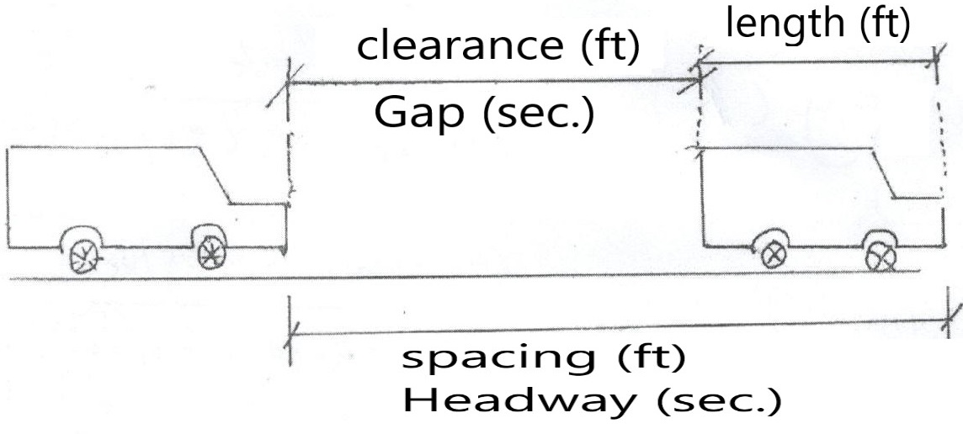

*the difference between spacing and clearance is the average length of a vehicle similarly, the difference between headway and gap is the time equivalent of the average length of a vehicle (L/S).

g= $h-\frac{L}{S}$

C= g * s

Where:

g= mean gap(sec.)

L=mean length of vehicle (m, ft)

C= mean clearance(m)

h= mean headway (sec.)

s= mean speed (m/sec) or (ft/sec)

*characteristics of un interrupted flow: -

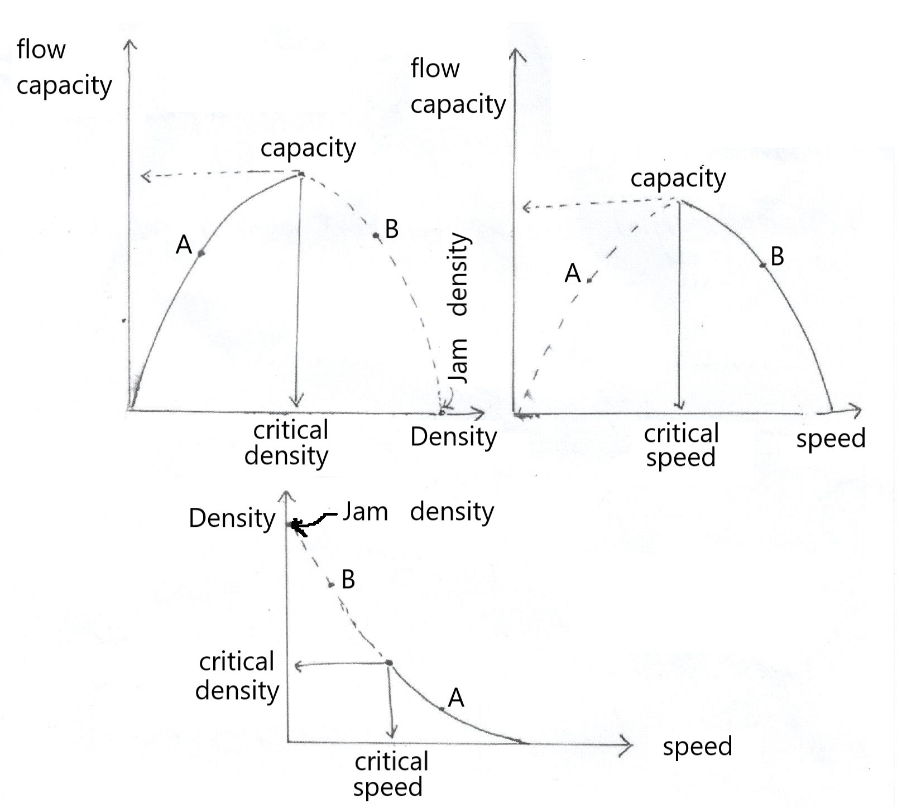

Where:

------- forced flow (high density, low speed) [B].

_____ stable flow (low density, high speed) [A].

1. When there are no cars on the facility, density is zero and rate of flow is also zero. Speed is purely theoretical for this condition and could be the speed of the first driver (may be high value).
2. When density becomes so high that all vehicles stop. (speed is zero) the rate of flow is also zero, because there is no movement and vehicles cannot ''pass'' a point on the roadway.

*The density at which all movement stop is call (Jam Density).

**Chapter Four**

**Element of Design**

**Visibility: -**Is an important requirement for the safety of travel on highway.

**Sight distance:-**It is the distance visible a head at certain highway section.

**There are three types: -**

1. **Stopping sight distance:** must be provided for all types of (highway) [SSD].
2. **Passing sigh distance:** for two lane two way hgw. [PSD].
3. **Decision sight distance:** for complex location [DSD].

**Stopping Sight Distance [SSD]:**

**SSD = d1+ d2**

Where:

d1 = lag distance (m): the distance traveled from the instant that of object is sighted to the instant that the brakes are applied.

d 1= 0.278*v*t

v= design speed (km/hr)

t= perception and reaction

2.5 sec. (Rural).

t=

1.5 sec. (Urban).

d2= braking distance (m): the distance required for stopping the vehicles after applying the brakes.

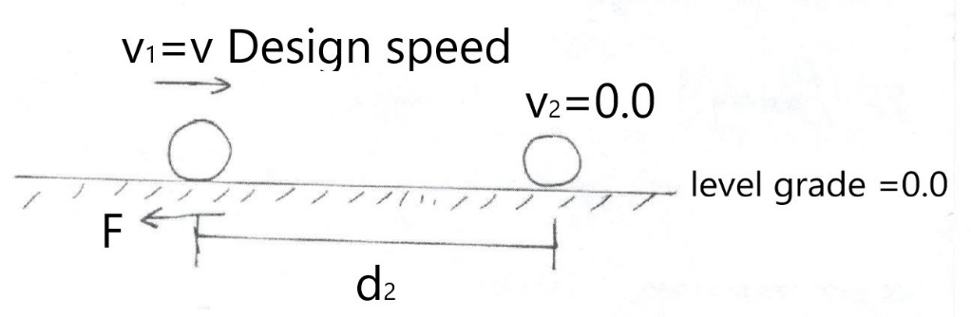

d2Where:

F = coefficient of friction, it depends on

-Type of topography (surface of pavement).

-Tire condition.

-Type of pavement.

0.55 → 0.62 drag surface

F = 0.27 → 0.36 wet surface

0.1 muddy surface

0.05 icy surface

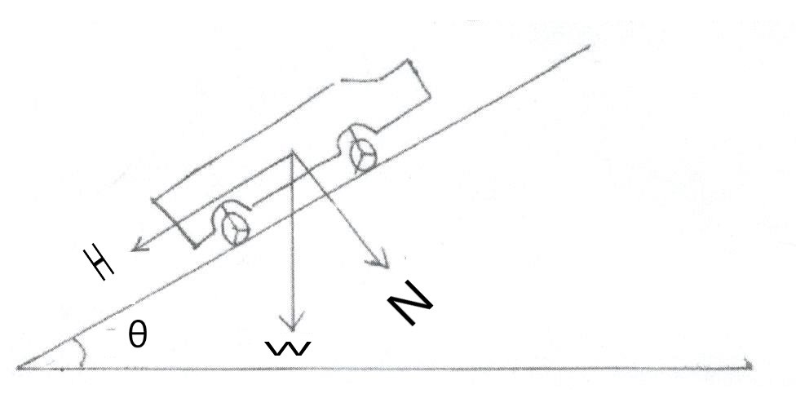**Effect of grade on braking distance:**

For θ ≈ small ≈ 0.0 → Then:

d2

Thus:

SSD= 0.278 v*t + $\frac{v^{2}}{254 (f±g)}$ (g=grade %) (ex. 3% = 0.03)

For h1 = 1.15m – 1.20m (eye driver height).

h2 = 0.15 – 0.2m (object height).

*SSD for (50-130) kph ≈ 65-300 m.

**Passing Sight Distance [PSD]:**

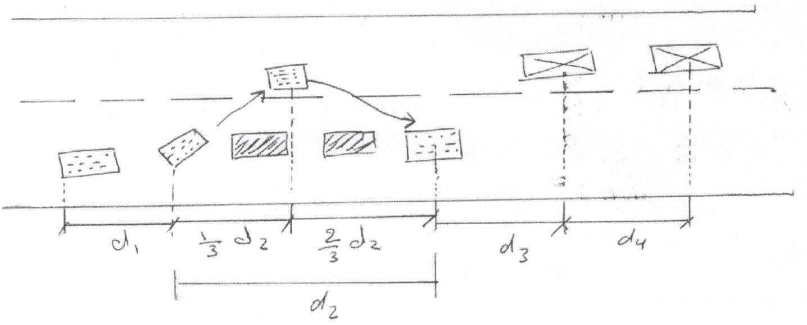It is the minimum PSD that should be available to a driver on a two-lane two way highway to enable him to overtake another vehicle safety.

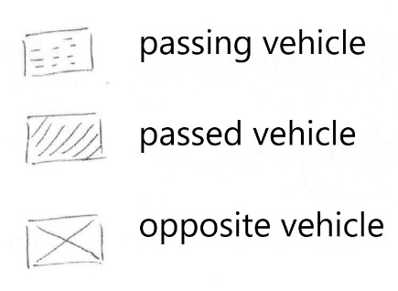Where:

Then:

PSD = d1+d2+d3+d4

Where:

d1= initial maneuver distance [Perception and reaction initial acceleration].

d1= 0.278*t1[v + - m]

Where:

t1= time of preliminary delay ≈ 4sec.

v= speed of passing vehicle (kph).

a= rate of acceleration →( 3-8) km/hr/sec [Private car]→(3/4 – 2) [truck]

m= difference between speeds of passing and passed vehicle (15-20) kph

d2= over taking distance (m)

d2= 0.278*v*t2

Where:

v= design speed for passing vehicle

t2= time required for using the opposite lane (10 sec.)

d3= safety distance (m) ≈ (30-90) m

d4= distance travelling by opposite vehicle after assuming its appearance, (m)

d4= d2

*min. PSD= (300-800) m

h1= eye driver height (1.15 – 1.20) m

h2= object height (1.37) m

**Decision Sight Distance[DSD]: -**

Or intermediate sight distance [ISD].

DSD or ISD = 0.278 * v * t/Where:

V= Design speed (kph)

t / = t1/ + t2/ + t3/

in which:

t1/= Detection and Recognition time (1.5 - 3) sec.

t2/= Decision and Response time (4.5 - 7) sec.

t3/= Lane change time (4.5 - 5) sec.

Thus:

DSD=2[SSD]

**Vertical alignment: -**

Parabolic curve are used for vertical alignment

1. Provide gradual change from one grade to another.
2. Provide pleasant appearance.

The general equation for vertical alignment

Y=K * X2

Where:

y= elevation of certain point on the alignment

x= distance of this point.

**General consideration: -**

1. Smooth grade line with gradual changes should always be preferable.
2. Avoid broken-back grade line.
3. Avoid the hidden dip.
4. Avoid using steep long momentum grades.
5. Avoid using sharp horizontal curve at the end of a steep grade.
6. Reduce or eliminate the grades at intersection.
7. Avoid vertical curve on horizontal curve.

Symmetrical.

*Vertical curve

Un symmetrical.

**Geometric Features: -**

1. All distances are measured horizontally and vertically.
2. Curves are required when (g2 – g1) ≥ 0.5%.

**Symmetrical vertical curve: -**

* Rate of change in grade (r) is constant.
* Equal length before and after the point of intersection.

X0: the distance from point at P.V.C to the turning point.

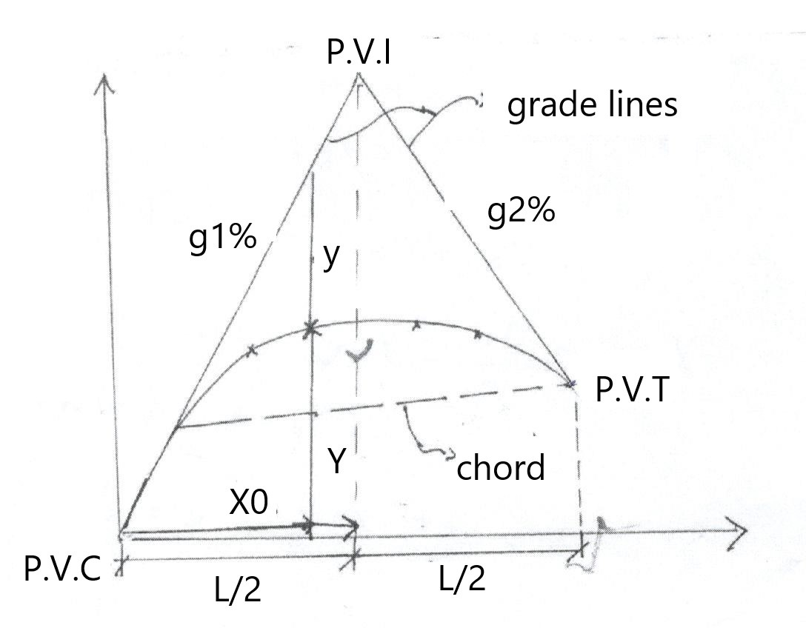

$\frac{dy}{dx}=slpe$, $\frac{d^{2}y}{dx^{2}}=r=constant (Rule)$

$\frac{dy}{dx}=rx+c$ [when $x=0.0 → \frac{dy}{{dx}_{1}}=g_{1}$]

$$g_{1}=c$$

$g_{2}=rL+c$ [when $x=L → \frac{dy}{{dx}_{2}}=g_{2}$]

$$then r=\frac{g_{2}-g_{1}}{L}$$

$$A=\left|g_{2}-g_{1}\right|$$

$:. Y= \frac{rx^{2}}{2}+g_{1}*x$------- 1

$$at any x \frac{y+Y}{x}=g_{1}$$

$$y=-\frac{1}{2}*r*x^{2}$$

Where: x: station

y: in meter (elevation)

r: % / station

x0: distance of peak point

$x_{0}=-\frac{g_{1}}{r}= x_{T }(turning point)$ = point of vertical curvature (p.v.c)

$$e=y →at x=\frac{L}{2} , e=\frac{1}{2}*\frac{A}{L}*{(\frac{L}{2})}^{2}=\frac{LA}{8}$$

$$then r=\frac{g_{2}-g_{1}}{L}=\frac{A}{L}$$

Elevation of any point at distance equal to x

$$E_{x}=E_{pvc}+g_{1}*x+\frac{1}{2}rx^{2}$$

**Unsymmetrical curve (vertical curve): -**

1. Consist of two symmetrical curve with different length with different value of (r).
2. There are common tangent parallel to the chord.

L1 = L2 for g1 = g2 or g1 ≠ g2

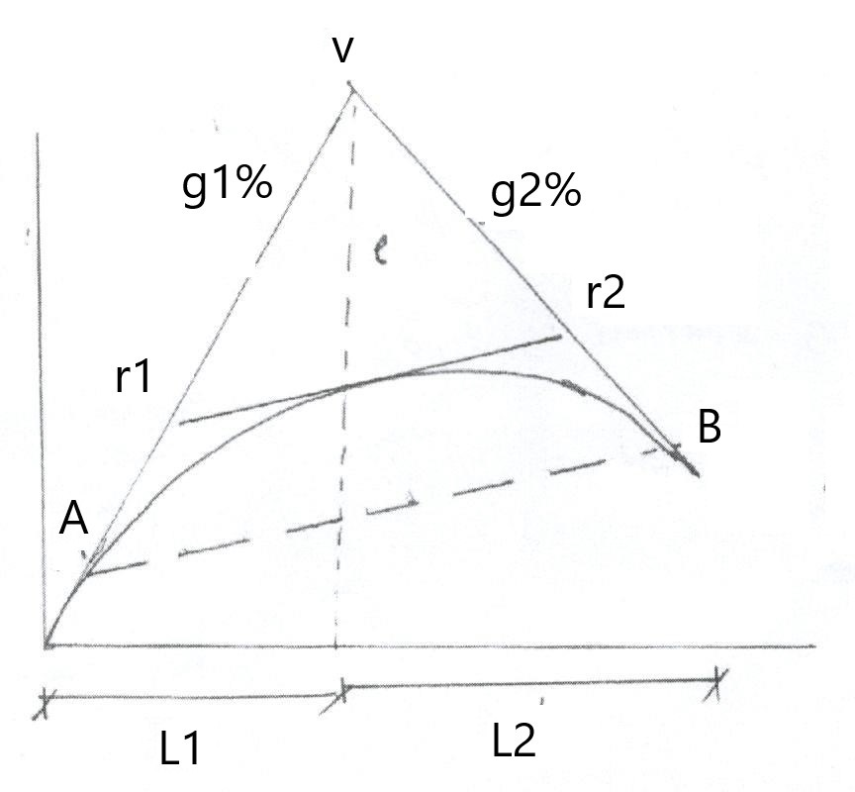

|  |  |
| --- | --- |
| Portion AV | Portion VB |
| $$r_{1}=\frac{A}{L}*\frac{L_{2}}{L_{1}}$$ $$y_{1}=\frac{1}{2}r_{1}{x_{1}}^{2}$$ $${XT}_{1}=-\frac{g_{1}}{r_{1}}≤L_{1}$$ $${Ex}_{1}=EA+g_{1}x_{1}+\frac{1}{2}r_{1}{x_{1}}^{2}$$ | $$r_{2}=\frac{A}{L}*\frac{L_{1}}{L_{2}}$$ $$y_{2}=\frac{1}{2}r_{2}{x_{2}}^{2}$$ $${XT}_{2}=-\frac{g_{2}}{r_{2}}≤L_{2}$$ $${Ex}_{2}=EB+g_{2}x_{2}+\frac{1}{2}r_{2}{x_{2}}^{2}$$ |

Where:

XT = The distance from p.v.c to the turning point.

Example: - Find the elevation of the lowest point on the curve? If you know the following data. L1=L2= station, g1= -6%, g2=4%, Epvc=118 m

Solution:

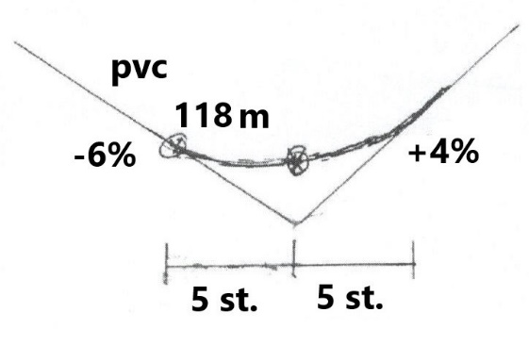

$r=\frac{g_{2}-g_{1}}{L}$ = $\frac{4-(-6)}{10}=1\%/station$

$$X_{T}=-\frac{g_{1}}{r_{1}}=\frac{-(-6)}{1}=6 station$$

$${Ex}_{T}=118+\left(-6\right)*6+\frac{1}{2}\left(1\right)*6^{2 }=100 m$$

**\*Sight Distance (For Control):**

1. Crest curve (safety requirement)
2. When S < L

Sight distance is included within the curve

Minimum length of crest curve $L_{min.}=\frac{{AS}^{2}}{200{(\sqrt{h_{1}}+\sqrt{h_{2}})}^{2}}$

Where: A%, S(m), h1 & h2 (m).

1. When S > L

$L_{min.}=2S- \frac{200{(\sqrt{h_{1}}+\sqrt{h_{2}})}^{2}}{A}$

Where: $L_{min.}$ = minimum length of curve.

S = SSD, PSD and DSD

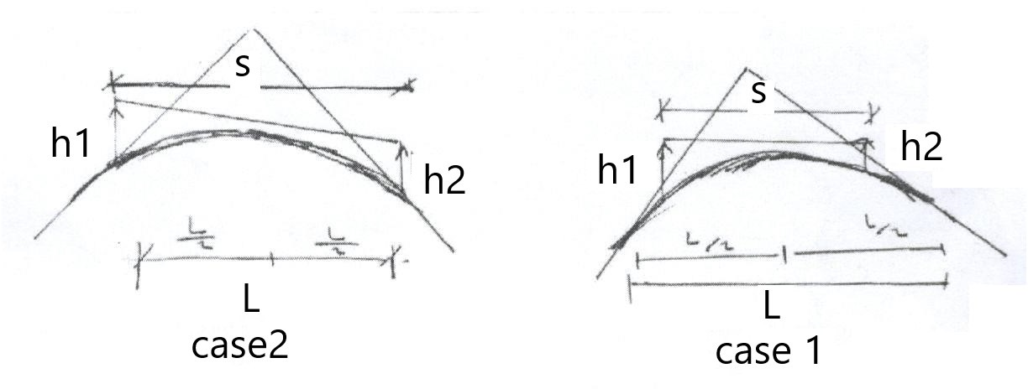

h1= 1.15 m constant.

h2= 0.15 m for stopping sight distance.

h3= 1.37 m for passing sight distance.

*If $e>h_{1}→S<L$

Where $e=\frac{LA}{8}$

Then for check only [ $e=\frac{SA}{8}$]

Example: crest curve symmetric type with total length equal to 300 m and

g1= 4%, g2=-3%, f=0.3,

it is safe to adopt speed = 110 kph on this section.

Solution:

$$e=\frac{SA}{8}=\frac{\left|-3-4\right|*\frac{300}{100}}{8}=2.6 >1.15 m$$

Then $S<L$

$$L_{min.}=\frac{{AS}^{2}}{200{(\sqrt{h_{1}}+\sqrt{h_{2}})}^{2}} →300=\frac{{\left|-3-4\right|S}^{2}}{200{(\sqrt{1.15}+\sqrt{0.15})}^{2}}$$

S = 135m

For SSD = 0.278 v*t + $\frac{v^{2}}{254 (f±g)}$ = 0.278 *110*(2.5) + $\frac{{110}^{2}}{254 (0.3-0.04)}=260m$

Thus SSD > Available sight distance

Then:

This crest curve is not safe.

What your recommendations?

Example: -

Intersection with two – lane two way hgw in unsymmetrical crest curve is constructed between two grade (+6% and -3%). The highest point on the curve is at 200m from p.v.c. check this section for passing condition if you know that the speed =80 km/hr and it need distance 350 m for this speed for safety passing.

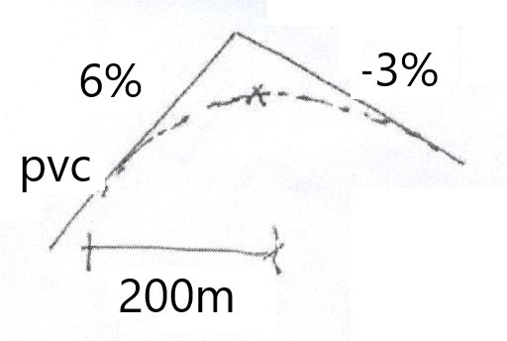Solution:

$X_{0}=-\frac{g_{1}}{r_{1}} →→2=-\frac{(+6)}{r}$ → r = -3%/sta.

$-3=\frac{\left(-3\right)*(+6)}{L} →→$ = 3 sta.

Then : $e=\frac{SA}{8}$ = $\frac{\left|-3-6\right|*3}{8}$ = 3.375m

: ' $e>h$ then : $S<L$ (h=1.15m) $→$

$$L=\frac{{AS}^{2}}{200{(\sqrt{h_{1}}+\sqrt{h_{2}})}^{2}} →300=\frac{{9*S}^{2}}{200{(\sqrt{1.15}+\sqrt{1.37})}^{2}}=183m$$

Then use PSD = 350m $>L_{available}$

$$∴the section is not safe to v=80 km/hr$$

**Critical Length of upgrade: -**

Max. length of upgrade causing reduction of 25 km/hr in the operating speed of loaded heavy vehicles.

|  |  |
| --- | --- |
| Up grade % | Critical length (m) |
| 3  4  5  6  >7 | 520  335  245  185  150 |

Climbing Lane: additional lane required when the critical length of upgrade exceeded and

If DHv > 1.2 * D.c (2 lane 2 way hgw.)

DHv > 1.3 * D.c (multi lane hgw.)