**The skin is particularly susceptible to invasion by pathogenic fungi.**

These organisms are widespread in nature, where they live as saprophytes or parasites, being unable to manufacture their own organic material. only very few are pathogenic to man and animal. Some species involve the superficial layers of the skin, while others invade the skin deeply,affecting other organs. In the superficial fungal infections, the skin and its appendages are solely or predominantly involved and each pathogenic fungus produces a more or less distinctive clinical pattern so that the causative organism may be suspected.

These superficial infections of the skin and its appendages are caused by a group of fungi called 'dermatophytes' which have the ability to digest and live on keratin. Infection is acquired by a direct contact with an infected animal or human, or from infected material. Due to the vulnerability of certain regions or structures of the skin to various fungi, **classification has been based on clinical grounds**

**1.Classification Based on Site**

Mycoses are classified as superficial, cutaneous, subcutaneous, or systemic (deep) infections depending on the type and degree of tissue involvement and the host response to the pathogen.

**2.Classification Based on Route of Acquisition**

Infecting fungi may be either exogenous or endogenous. Routes of entry for exogenous fungi include airborne, cutaneous or percutaneous. Endogenous infection involves colonization by a member of the normal flora or reactivation of a previous infection.

**3.Classification Based on Virulence**

Primary pathogens can establish infections in normal hosts. Opportunistic pathogens cause disease in individuals with compromised host defense mechanisms.

## Superficial and Cutaneous Mycoses

Superficial Mycoses include the following fungal infections and their etiological agent: black piedra (*Piedraia hortae*), white piedra (*Trichosporon beigelii*), pityriasis versicolor (*Malassezia furfur*), and tinea nigra (*Phaeoannellomyces werneckii*).

*Hortaea werneckii* is the etiologic agent of tinea nigra, a superficial cutaneous mycosis typically involving either the palms of the hands or soles of the feet, and frequently acquired in subtropical coastal locations. Infection with this salt-tolerant organism is postulated to occur through exposure of superficially abraded skin to drying tidal pools. The olivaceous to black colonies are smooth, slimy, and yeastlike and show restricted growth. Hyphae (width up to 6 μm) are densely septate, thick-walled, and brown. Intercalary or lateral conidiogenous cells with prominent annellations produce smooth one- to two-celled ellipsoidal conidia that are initially hyaline but later become pale olivaceous. Conidia may exhibit budding and often develop into aggregates of chlamydoconidia. Tolerance of 10% NaCl, lack of growth at 37°C, and the broad annellated zones allow differentiation from *Exophiala* species.

Tinea nigra is clinically characterized by a sharply marginated, light-brown to black, non-scaly, oval-shaped macula. In some patients, this macule is mottled and might be irregular in shape. Although lesions present usually as single and asymptomatic and they are mainly observed on the palmar surface , involvement of the plantar surface, neck, or trunk can also occur. Hyperhidrosis could be a risk factor. Lesions of tinea nigra are quite characteristic, but they can be clinically mis-diagnosed as junctional melanocytic nevus and even as malignant melanoma.

Dark-colored, branching, septate hyphae and round to oval yeast forms are present in the superficial layers of the stratum corneum. There is generally no inflammatory response.

Tinea nigra is effectively treated with twice daily applications of imidazole or ciclopirox. Topical tolnaftate and oral griseofulvin are reported to be ineffective.

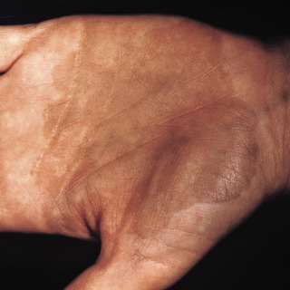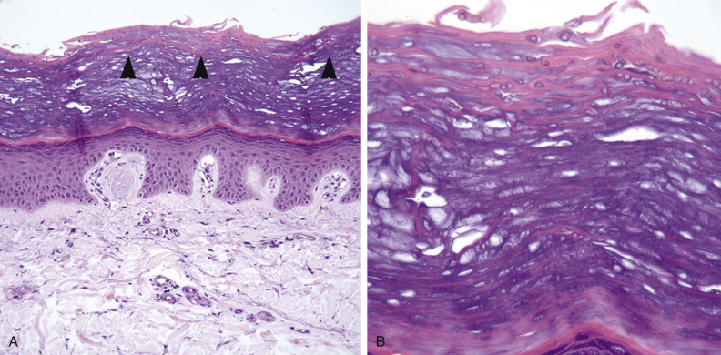

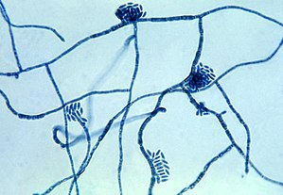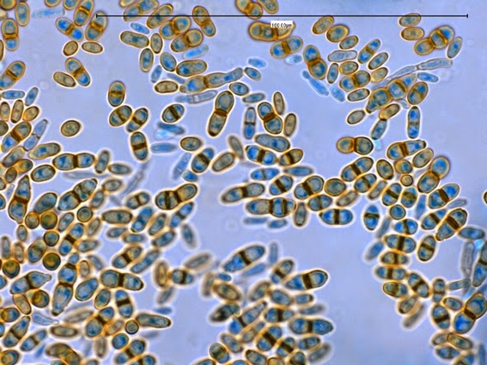

**Dematiaceuos (black fungi)**

pigmented fungi have been implicated in human disease . The vast majority are filamentous fungi or moulds, though a few yeast species are also important pathogens. Though they represent a very heterogeneous group of fungi, the distinguishing characteristic common to all these various species is the presence of melanin in their cell walls, which imparts the dark color to their conidia or spores and hyphae.The colonies are typically brown to black in color avariety of infectious syndromes are attributed to dematiaceous fungi .Two unique conditions, mycetoma and chromoblastomycosis, are caused by a small number of species

In the case of mycetoma and chromoblastomycosis, pathognomonic histologic findings are very useful .The presence of black mycotic granules or grains can establish the diagnosis of mycetoma due to dematiaceous fungi. Histologically, they appear to be composed of fungal cells surrounded by a dense extracellular matrix composed primarily of a melanin compound, which gives it a dark color.

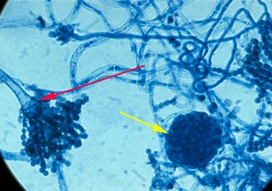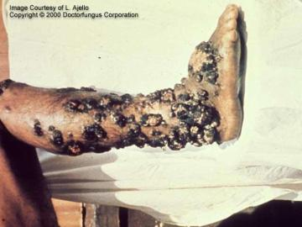

**The Cutaneous Mycoses**

These are superficial fungal infections of the skin, hair or nails.  No living tissue is invaded, however a variety of pathological changes occur in the host because of the presence of the infectious agent and its metabolic products.

About 20 species in three genera – *Epidermophyton, Microsporum, Trichophyton* – all with the ability to utilize keratin, grow in the non-living tissues of hair, nails, and skin, in the region above the layers where keratin is deposited. They cause a complex of diseases known clinically as tinea (ringworm) in humans and other vertebrates, and are spread in a keratin-tissue fragment containing viable fungus.

***Trichophyton*** is a [genus](https://en.wikipedia.org/wiki/Genus) of [fungi](https://en.wikipedia.org/wiki/Fungi), which includes the [parasitic](https://en.wikipedia.org/wiki/Parasitic) varieties that cause [tinea](https://en.wikipedia.org/wiki/Tinea" \o "Tinea), including [athlete's foot](https://en.wikipedia.org/wiki/Athlete%27s_foot), [ringworm](https://en.wikipedia.org/wiki/Ringworm), [jock itch](https://en.wikipedia.org/wiki/Jock_itch), and similar infections of the nail, beard, skin and scalp. Trichophyton fungi are [molds](https://en.wikipedia.org/wiki/Mold) characterized by the development of both smooth-walled macro- and [microconidia](https://en.wikipedia.org/wiki/Microconidia" \o "Microconidia). [Macroconidia](https://en.wikipedia.org/wiki/Conidia" \o "Conidia) are mostly borne laterally directly on the hyphae or on short pedicels, and are thin- or thick-walled, [clavate](https://en.wikipedia.org/wiki/Glossary_of_botanical_terms" \l "C" \o "Glossary of botanical terms) to [fusiform](https://en.wiktionary.org/wiki/fusiform" \o "wikt:fusiform). Macroconidia are few or absent in many species. Microconidia are spherical, pyriform to clavate or of irregular shape.

*Trichophyton concentricum* causes "Malabar itch", a skin infection consisting of an eruption of a number of concentric rings of overlapping scales forming [papulosquamous](https://en.wikipedia.org/wiki/Papulosquamous" \o "Papulosquamous) patches.

The fungi can easily spread to other areas of the body as well and to the host's home environs (socks, shoes, clothes, showers, bathtubs, counters, floors, carpets, etc.).

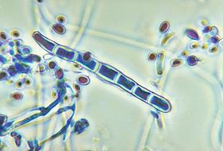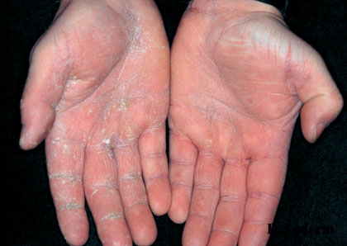

***Microsporum***is a filamentous keratinophilic fungus included in the group of [dermatophytes](http://drfungus.org/knowledge-base/dermatophytes/). While the natural habitat of some of the *Microsporum* spp. is soil (the geophilic species), others primarily affect various animals (the zoophilic species) or human (the anthropophilic species). Some species are isolated from both soil and animals (geophilic and zoophilic). Most of the *Microsporum* spp. are widely distributed in the world while some have restricted geographic distribution. *Microsporum* is the asexual state of the fungus and the telemorph phase is referred to as genus *Arthroderma* .

*Microsporum* is one of the three genera that cause [dermatophytosis](http://drfungus.org/knowledge-base/fungal-infections-skin-skin-structures-intro/). Dermatophytosis is a general term used to define the infection in hair, skin or nails due to any dermatophyte species. Similar to other dermatophytes, *Microsporum* has the ability to degrade keratin and thus can reside on skin and its appandages and remains noninvasive. The pathogenesis of the infection depends on the natural reservoir of the species

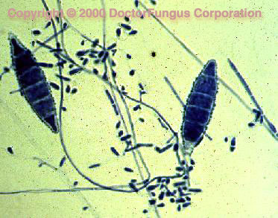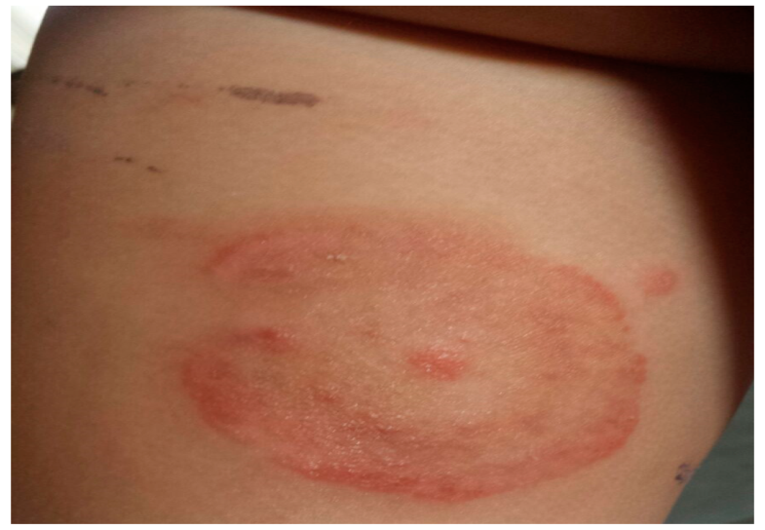

***Epidermophyton*** is a filamentous fungus and one of the three fungal genera classified as [dermatophytes](http://mycosesstudygroup.org/thefungi/dermatophytes.htm). It is distributed worldwide. The colonies of *E. floccosum* grow moderately rapidly and mature within 10 days. Following incubation at 25 °C on potato dextrose agar, the colonies are brownish yellow to olive gray or khaki from the front. From the reverse, they are orange to brown with an occasional yellow border. The texture is flat and grainy initially and become radially grooved and velvety by aging. The colonies quickly become downy and sterile . The infection is restricted to the nonliving cornified layers of epidermis since the fungus lacks the ability to penetrate the viable tissues of the immunocompetent host . Disseminated infections due to any of the dermatophytes are very unlikely due to the restriction of the infection to keratinized tissues.

