**Subcutaneous Mycoses**

|  |  |  |
| --- | --- | --- |
| **Disease** | **Causative organisms** | **Incidence** |
| Sporotrichosis | *Sporothrix* spp. | Rare |
| Chromoblastomycosis | *Fonsecaea, Phialophora,* *Cladophialophora*etc. | Rare |
| Phaeohyphomycosis | *Cladophialophora, Exophiala,* *Bipolaris, Exserohilum* etc | Rare |
| Mycotic mycetoma | *Scedosporium, Madurella, Trematosphaeria,  Acremonium, Exophiala etc.* | Rare |
| Subcutaneous zygomycosis (Entomophthoromycosis) | *Basidiobolus ranarum* *Conidiobolus coronatus* | Rare |
| Subcutaneous zygomycosis  (Mucormycosis) | *Rhizopus, Mucor, Rhizomucor,* *Lichtheimia, Saksenaea* etc. | Rare |
| Lobomycosis | *Loboa loboi* | Rare |
| Rhinosporidiosis | *Rhinosporidium seeberi* | Rare |

These are chronic, localized infections of the skin and subcutaneous tissue following the traumatic implantation of the a etiologic agent. The causative fungi are all soil saprophytes of regional epidemiology whose ability to adapt to the tissue environment and elicit disease is extremely variable.

**Sporotrichosis**

Sporotrichosis is primarily a chronic mycotic infection of the cutaneous or subcutaneous tissues and adjacent lymphatics characterized by nodular lesions which may suppurate and ulcerate. Infections are caused by the traumatic implantation of the fungus into the skin, or very rarely, by inhalation into the lungs. Secondary spread to articular surfaces, bone and muscle is not infrequent, and the infection may also occasionally involve the central nervous system, lungs or genitourinary tract.

**Clinical manifestations:**

[[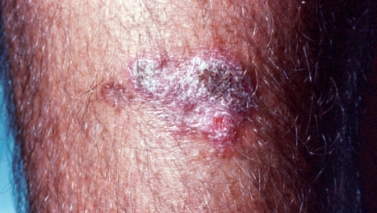](https://mycology.adelaide.edu.au/images/sporo-clin3.jpg)](https://mycology.adelaide.edu.au/images/sporo-clin3.jpg)

**Fixed cutaneous sporotrichosis:**Primary lesions develop at the site of implantation of the fungus, usually at more exposed sites mainly the limbs, hands and fingers. Lesions often start out as a painless nodule which soon become palpable and ulcerate often discharging a serous or purulent fluid. Importantly, lesions remain localised around the initial site of implantation and do not spread along the lymphangitic channels. Isolates from these lesions usually grow well at 35C, but not at 37C.

**Lymphocutaneous sporotrichosis:**Primary lesions develop at the site of implantation of the fungus, but secondary lesions also appear along the lymphangitic channels which follow the same indolent course as the primary lesion ie they start out as painless nodules which soon become palpable and ulcerate. No systemic symptoms are present. Isolates from these lesions usually grow well at both 35C and 37C.

[[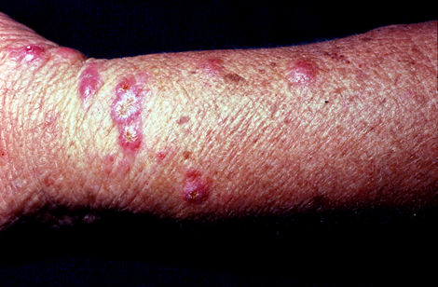](https://mycology.adelaide.edu.au/images/sporo-clin2.jpg)](https://mycology.adelaide.edu.au/images/sporo-clin2.jpg)[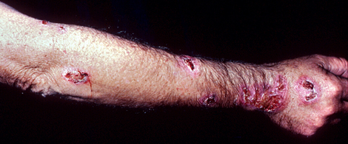](https://mycology.adelaide.edu.au/images/sporo-clin1.jpg) **Pulmonary sporotrichosis:**This is a rare entity usually caused by the inhalation of conidia but cases of haematogenous dissemination have been reported. Symptoms are nonspecific and include cough, sputum production, fever, weight loss and upper-lobe lesion. Haemoptysis may occur and it can be massive and fatal. The natural course of the lung lesion is gradual progression to death.

**Osteoarticular sporotrichosis:**Most patients also have cutaneous lesions and present with stiffness and pain in a large joint, usually the knee, elbow, ankle or wrist. Osteomyelitis seldom occurs without arthritis; the lesions usually confined to the long bones near affected joints.

Other rare forms of sporotrichoisis include endophthalmitis, chorioretinitis and meningitis.

[[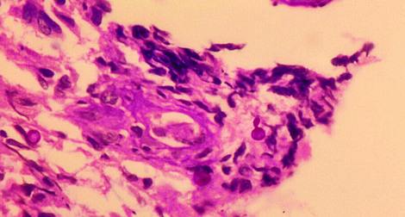](https://mycology.adelaide.edu.au/images/sporo-histo.jpg)](https://mycology.adelaide.edu.au/images/sporo-histo.jpg)

**Laboratory diagnosis:**

**1. Clinical material:**  
A tissue biopsy is the best specimen.

**2. Direct Microscopy:**  
Tissue sections should be stained using PAS digest, Grocott's methenamine silver (GMS) or Gram stain.

**Interpretation:**   
Look for small narrow base budding yeast cells (2-5um). **Note** they are often present in very low numbers and may be difficult to find. PAS and GMS stains are essential.

**3. Culture:**   
Clinical specimens should be inoculated onto primary isolation media, like Sabouraud's dextrose agar and Brain heart infusion agar supplemented with 5% sheep blood.

**Interpretation:**A positive culture from a biopsy should be considered significant.

**4. Serology:**   
Serological tests are of limited value in the diagnosis of Sporotrichosis.

**5. Identification:**Hyphomycete characterized by thermal dimorphism and clusters of ovoid, denticulate conidia produced sympodially on short conidiophores.

**6. Causative agents:***Sporothrix schenckii*complex.

A mycotic infection of humans and animals caused by a number of different fungi and actinomycetes characterized by draining sinuses, granules and tumefaction. The disease results from the traumatic implantation of the aetiologic agent and usually involves the cutaneous and subcutaneous tissue, fascia and bone of the foot or hand. Sinuses discharge serosanguinous fluid containing the granules which vary in size, colour and degree of hardness, depending on the aetiologic species, and are the hallmark of mycetoma. World-wide distribution but most common in bare-footed populations living in tropical or subtropical regions. Aetiological agents include*Madurella, Acremonium, Pseudallescheria, Exophiala, Leptosphaeria, Curvularia, Fusarium, Aspergillus* etc.

**Clinical Manifestations:**

Mycetoma is a chronic, suppurative infection of the subcutaneous tissue and contiguous bone. The clinical features are fairly uniform, regardless of the organism involved. The feet are the most coomon site for infection and account for at least two-thirds of cases. Other sites include the lower legs, hands, head, neck, chest, shoulder and arms. Most cases start out as a small hard painless nodule which over time begins to soften on the surface and ulcerate to discharge a viscous, purulent fluid containing grains. The infection slowly spreads to adjacent tissue, including bone, often causing considerable deformity. Sinuses continue to discharge serosanguinous fluid containing the granules which vary in size, colour and degree of hardness, depending on the aetiologic species. These grains are the hallmark of mycetoma.

[[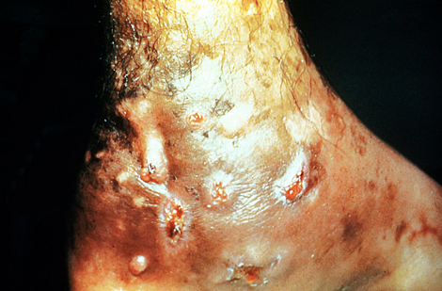](https://mycology.adelaide.edu.au/images/mycetoma-clin1.jpg)](https://mycology.adelaide.edu.au/images/mycetoma-clin1.jpg)[[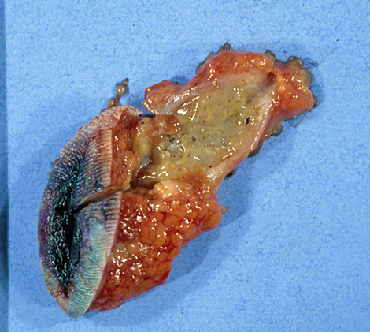](https://mycology.adelaide.edu.au/images/mycetoma-clin2.jpg)](https://mycology.adelaide.edu.au/images/mycetoma-clin2.jpg)

**Laboratory Diagnosis:**

**1. Clinical Material:**   
Tissue biopsy or excised sinus, serosanguinous fluid containing the granules which vary in size, colour and degree of hardness, depending on the aetiologic species.

[[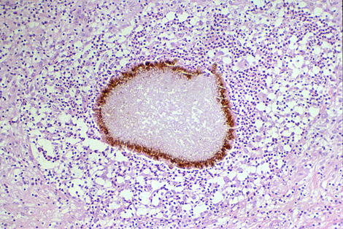](https://mycology.adelaide.edu.au/images/mycetoma-grain.jpg)](https://mycology.adelaide.edu.au/images/mycetoma-grain.jpg)

**2. Direct Microscopy:**   
Serosanguinous fluid containing the granules should be examined using either 10% KOH and Parker ink or calcofluor white mounts, and tissue sections should be stained using H&E, PAS digest, and Grocott's methenamine silver (GMS).

**Interpretation:**   
The presence of white to yellow or black pigmented grains, from a patient with supporting clinical symptoms should be considered significant. Biopsy and evidence of tissue invasion is of particular importance. Remember direct microscopy or histopathology does not offer a specific identification of the causative agent.

**3. Culture:**   
Clinical specimens should be inoculated onto primary isolation media, like Sabouraud's dextrose agar.

**4. Serology:**There are currently no commercially available serological procedures for the diagnosis of mycetoma.

**5. Identification:**   
Characteristic clinical, microscopic and culture features.

**6. Causative agents:***Acremonium*sp.,*Aspergillus nidulans, Madurella grisea, Madurella mycetomatis, Scedosporium apiospermum.*